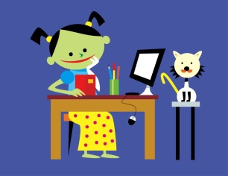
Technology in Literacy

Book Wizard: Book wizard allows you to search children’s books for their reading level. The app allows you to scan a barcode and find the book’s reading level and grade equivalent. www.scholastic.com/bookwizard

Raz-Kids: Raz-Kids allows students to read books on their level and answer reading comprehension questions that go along with the book. Students are able to listen to the book, record themselves reading the book, and answer questions. Parents can sign up for emails to track students’ progress. www.raz-kids.com/main/Login

Storyboard That: Students can create storyboards and write stories. www.storyboardthat.com

Starfall: This is great for young readers. Starfall engages early readers by teaching and reviewing letter sounds and progressing toward the student reading books. www.starfall.com

Storyline online: Famous people read picture books online for students to enjoy. http://www.storylineonline.net/

Other apps:
iMovie: This has endless possibilities. Students can create book trailers, advertise books, record themselves reading, retell a story, or many other amazing ideas they can come up with.

Endless ABC and Endless Reader (for beginning readers)

Bob books (for beginning readers)

*Don’t forget our own Media Center has eBooks too! Visit the ELE Media Center wiki to access the books. http://wassell.cmswiki.wikispaces.net/e-Books

